Nepal College of Information Technology
Balkumari Lalitpur
Unit Test Spring Semester 2008

Electronic Circuits

Year: 2008 FM: 70
Sem: IV PM: 35
Program ELX Time: 2hrs

1. a. Draw the small signal model of emitter follower amplifier and derive the expression for input and output impedance and voltage gain. [7]
b. For the given figure calculate output voltage in amplifier as shown. Let β=100. [8]

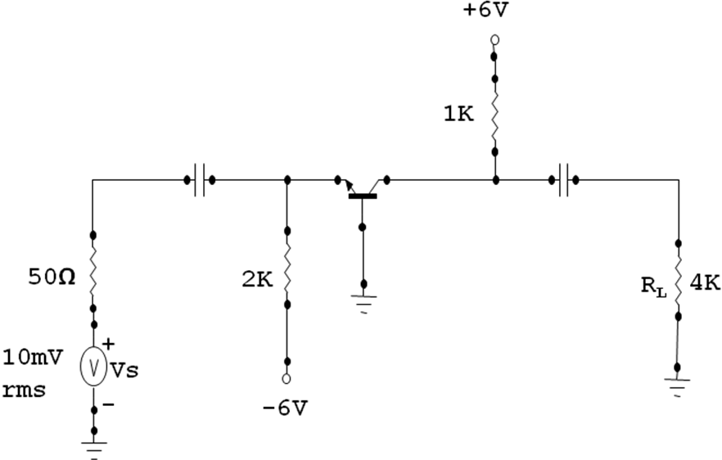

2. a. For the given circuit, two transistors are identical, β=100,r_{c}=1MΩ and r_{e}=25Ω find overall voltage gain (v_{l} /v_{s}). [8]

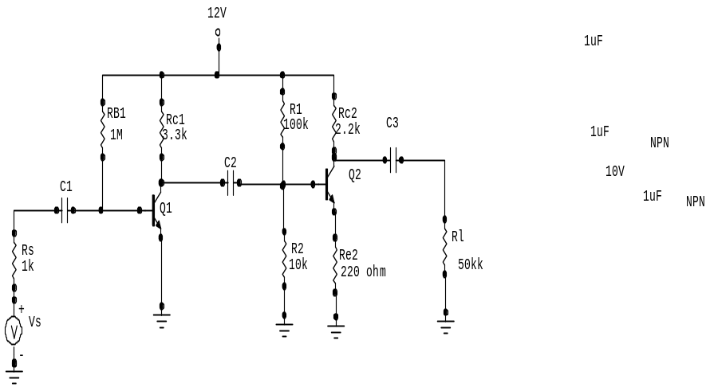

b. “Darlington pair is referred as “super beta” transistor circuit.” Verify it . [7]

3. a. Define distortion and describe different types of distortion that occurs in amplifier. [7]

b. Explain about the frequency response of an amplifier. [8]

4 a. What is Millers-effect? Prove that C_{M}=C_{C}(1-A_{V}) ,Where C_{C} is capacitance connected between the input and the output of an amplifier, A_{V} is voltage gain and C_{M} is miller capacitance. How this affects the high frequency response of inverting amplifier. [7]

b. Explain class B operation and show this concept is utilized in push-pull amplifier Find the power conversion efficiency of this operation. [8]
5. Write shorts notes on: (Any Two) [10]
a. Cross over distortion.
b. Choice of transistor configuration in cascade
c. Complementary-symmetry push-pull class-B amplifier.

"This set has not been used anywhere else."

